Installation of PG – HRIS – SYSTEM

Kindly install the ff:
. Firefox Setup 3.0.6.exe
- AdbeRdr90_en_US.exe
- install_flash_player.exe

Reason :
- For the implementation of the PG-HRIS-SYSTEM.

Instructions :

- Install the ff:
. Firefox Setup 3.0.6.exe
- AdbeRdr90_en_US.exe
- install_flash_player.exe

After the Installation :

- On the Tools menu-> Click options
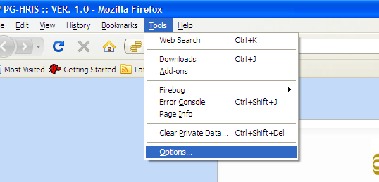

- Type : http://192.168.200.226/PG-HRIS-SYSTEM/ in the Home Page Field, then click the OK Button. (Uncheck the Show the Downloads window when downloading afile.)
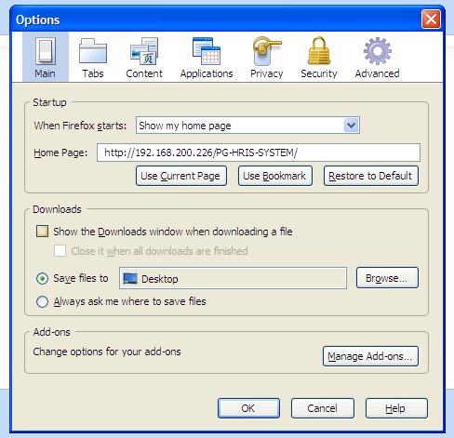

- Close the Web Browser.
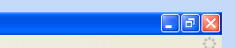

- Rename the Label of the Mozilla Firefox Icon.
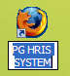

- Test the module, by “double clicking” the PG HRIS SYSTEM icon.

- Expected that the Interface will be “like” the image below.
